# Project Report

# Entrepreneurship in India

SUBMITTED IN THE PARTIAL FULFILLMENT REQUIREMENT FOR THE AWARD OF DEGREE OF

# Bachelor of Technology

(Computer

Science

and Engineering)

**SUBMITTED BY -**

1.Dev Gupta -230685

2.Vikramjeet Singh-230683

3.Astitva Saxena-230690

4.Rajyawardhan Godara-230684

**UNDER THE SUPERVISION OF**

Dr. Kiran Sharma Assistant Professor BMU

**School of Engineering and Technology**

# BML MUNJAL UNIVERSITY Gurugram, Haryana - 122413

# Dec 2024

**CANDIDATE'S DECLARATION**

We hereby certify that the six-month project titled **“Entrepreneurship in India”**, undertaken in partial fulfilment of the requirements for the award of the Degree of Bachelor of Technology in the School of Engineering and Technology (SOET) at BML Munjal University, is an authentic record of our own work carried out from July 2024 to December 2024 under the supervision of Dr. Kiran Sharma.

SUBMITTED BY -

## 1.Dev Gupta

## 2.Vikramjeet Singh

## 3.Astitva Saxena

## 4.Rajyawardhan Godara

This is to certify that the above statement made by the candidate is correct to the best of my knowledge.

Dr. Kiran Sharma Assistant Professor BMU

**ABSTRACT**

This study examines entrepreneurship research trends using a dataset of 2,523 entries after refining the original dataset from 3,249 records. The data focuses on articles, reviews, and conference papers, excluding non-English documents and publications from 2025. The analysis explores publication patterns over time, country collaborations, and the distribution of open-access publications.

Key findings include a total of 22,226 citations and significant trends in document types, with articles making up the majority of publications. The study identifies top authors, journals, publishers, and countries, with India emerging as a central contributor in global collaborations. Notable country pairings include India-United States and India-United Kingdom.

Further analysis highlights the increasing emphasis on topics like innovation and entrepreneurship, with a focus on business development, social impact, and education. The study also investigates into publisher contributions, addressing inconsistencies in naming conventions and ensuring accurate counts.

Overall, the research provides valuable insights into publication trends, global research networks, and thematic patterns within the field of entrepreneurship.

**ACKNOWLEDGEMENT**

We are highly grateful to **Dr. Kiran Sharma, Assistant Professor**, BML Munjal University, Gurugram, for providing supervision to carry out the Project-1 Mentorship from July-December 2024.

**Dr. Kiran Sharma** has provided great help in carrying out our work and is acknowledged with reverential thanks. Without the wise counsel and able guidance, it would have been impossible to complete the training in this manner.

We would like to express thanks profusely to thank **Dr. Kiran Sharma**, for stimulating us time to time. We would also like to thank entire team of BML Munjal University and also my friends who devoted their valuable time and helped us in all possible ways towards successful completion.

**LIST OF FIGURES**

|  |  |  |
| --- | --- | --- |
| **Figure No** | **Figure Description** | **Page No** |
| 1 | Numbers of papers published every year | 11 |
| 2 | Count of article, Review and Conference Paper | 12 |
| 4 | Open Access Distribution | 13 |
| 5 | Word Cloud | 14 |
| 6 | Top 10 single country | 15 |
| 7 | Top 10 Sub Pair | 16 |

**LIST OF TABLES**

|  |  |  |
| --- | --- | --- |
| **Table No** | **Table Description** | **Page No** |
| 1 | Decade wise trend analysis | 17 |
| 2 | Sequential Pid | 18 |
| 3 | Analysis of document type like article, review, conference papers. | 19 |
| 4 | Top 10 countries count | 20 |
| 5 | Top 10 Sub Pair | 21 |
| 6 | Top 10 journals | 22 |
| 7 | Top 10 Publishers | 23 |

**TABLE OF CONTENTS**

**Table of Contents Page No.**

Candidate’s Declaration 1

Abstract 2

Acknowledgment 3

List of Figures 4

List of Tables 5

1. Introduction to Organization and Project 7
2. Literature Review 8
3. Objectives 9
4. Data and Methodology 10
5. Results 11
6. Conclusion 24
7. References 25

**INTRODUCTION**

Entrepreneurship in India has gained significant consideration in recent times due to its impact on job creation and social transformation and economic growth.

This project focuses on **research on entrepreneurship**, specifically from 1976 to 2024 **in India**. This study objects to identify key trends such as the rise in collaborative research and the increasing emphasis on entrepreneurial ecosystems using a dataset of about 2,500 entries.

It uses bibliometric methods to analyze trends in academic research related to entrepreneurship that highlights the growing importance of innovation and entrepreneurship in overall economic development. The research relies on data from databases such as Scopus to uncover patterns in publications, authorship, and collaboration.

The dataset highlights the rising trends of academic research in entrepreneurship as well as provides insights into the most productive authors, top journals and influential publishers. The study also focuses the geographical distribution of those research affiliations who have explored role of India as a central contributor in global research collaborations.

In summary, this analysis not only examines the publication trends over time but also offers valuable insights into how India has played a significant role through entrepreneurship research in shaping global and local innovation strategies.

**LITERATURE REVIEW**

Entrepreneurship has grabbed a significant interest of the academicians in economic and social growth. Various studies have discovered its dynamics, ranging from publication trends to international collaborations. Recent analyses of bibliometric datasets provide a deeper understanding of the global landscape of entrepreneurship research.

Publications in entrepreneurship have seen a steady rise over recent decades. Sharma et al. (2023) emphasized the growing role of bibliometric methods to uncover research trends, especially in India. The datasets highlighted the dominance of collaborative works with India emerging as a central hub for global research partnerships.

Scopus datasets have revealed that articles dominate the field, accounting for over 80% of publications. Review articles, although fewer, display a higher citation impact, emphasizing their importance in consolidating existing knowledge. Zhang et al. (2020) has discussed the impact of conference papers in entrepreneurship and introducing emerging concepts but with limited long-term citation impact.

Top-rated journals and authors reflect a concentrated effort in specific areas. For instance, highest citation-per-paper ratio of the Journal of Entrepreneurship from Sage Publications had showcased its influence. Similarly, publishers like Elsevier and John Wiley and Sons made lead in total citations that is indicative of their high-quality and diverse journal portfolios.

The frequent collaborations with Indian researchers reflect strong bilateral ties of India with that of United States and United Kingdom as studied by Wang et al. (2021) and Elango et al. (2020). Global collaboration patterns revealed India's strong presence in the dataset. India-United States and India-United Kingdom partnerships lead in frequency, showcasing India's growing influence in international research. The emergence of smaller players like Malaysia and Saudi Arabia also reflects a shift toward more inclusive global collaborations.

The multidisciplinary nature of the field is proved by thematic analyses through visual tools such as word clouds, and recurring keywords like "innovation," "business development," and "strategy”. Meanwhile, funding patterns revealed that Indian publications rely on both domestic and international support with significant contributions from organizations like ICSSR and publishers like Emerald.

In a nutshell, the literature highlights an increasing focus on entrepreneurship research by growing global collaborations, thematic diversification and an expanding ecosystem of high-impact publications. This review consolidates insights into the publication patterns, author contributions and global partnerships, offering a comprehensive perspective on the academic evolution of entrepreneurship.

**OBJECTIVES**

1. **Identify Decadal Trends**: Investigate decade-wise trends in entrepreneurship publications to understand the evolution of research focus over time.
2. **Explore Country Collaborations**: Analyze the unique and common country pairs in collaborative research to reveal global research dynamics.
3. **Assess Publication Productivity**: Evaluate year-wise publication counts to identify periods of high or low research activity.
4. **Document Type Analysis**: Classify and compare the distribution of document types (articles, reviews, conference papers) and their impact on research visibility.
5. **Top Affiliations and Countries**: Highlight the leading affiliations and countries contributing to entrepreneurship research.
6. **Open Access Trends**: Assess the distribution and trends of open-access publications in entrepreneurship research.
7. **Ranking Analysis**: Identify and analyze the top-performing journals, publishers, and countries based on publication volume.
8. **Citation Insights**: Compare average citation counts across different document types to assess their academic influence.
9. **Visualizing Key Insights**: Use word clouds and visual charts to summarize and present key terms and patterns in the research corpus.

10. **Funding and Publisher Insights**: Investigate funding trends and their relationship with top publishers, focusing on Indian contributions to the field.

**DATA AND METHODOLOGY**

**Data cleaning and preparation:**

1. Removing 2025 data entries.
2. Removing non-English documents (i.e., French and Spanish language records).
3. Filtering the authors by first, last and middle name from each row and assigning them a separate ID.
4. Filtering document type like Article, Review, Conference papers.
5. Changing the All-open access to 1 and non-open access entries to 0 in the open access column.
6. Filtering the top 10 Journals on the basis of total papers and total citations.
7. Filtering the top 10 publishers on the basis of similar names converting them to one name.
8. Making a word cloud based on author keywords column in which lowercase and uppercase are treated same.
9. From affiliations columns separated all the countries.
10. Funding details of all Indian publishers.

**Methodology:**

* **Exploratory Data Analysis (EDA)**:

Calculation of average citations per document type (article, review, conference papers).

Filtering data in which there are only English records and removing non-English data.

Filtering the data by removing the 2025-year data.

Plotting a graph using EDA to show how many documents were published each year between 1999-2024.

* **Software/Tools**: We have used Python for writing the code for performing the EDA and all the data were stored in CSV or excel file.

**RESULTS**

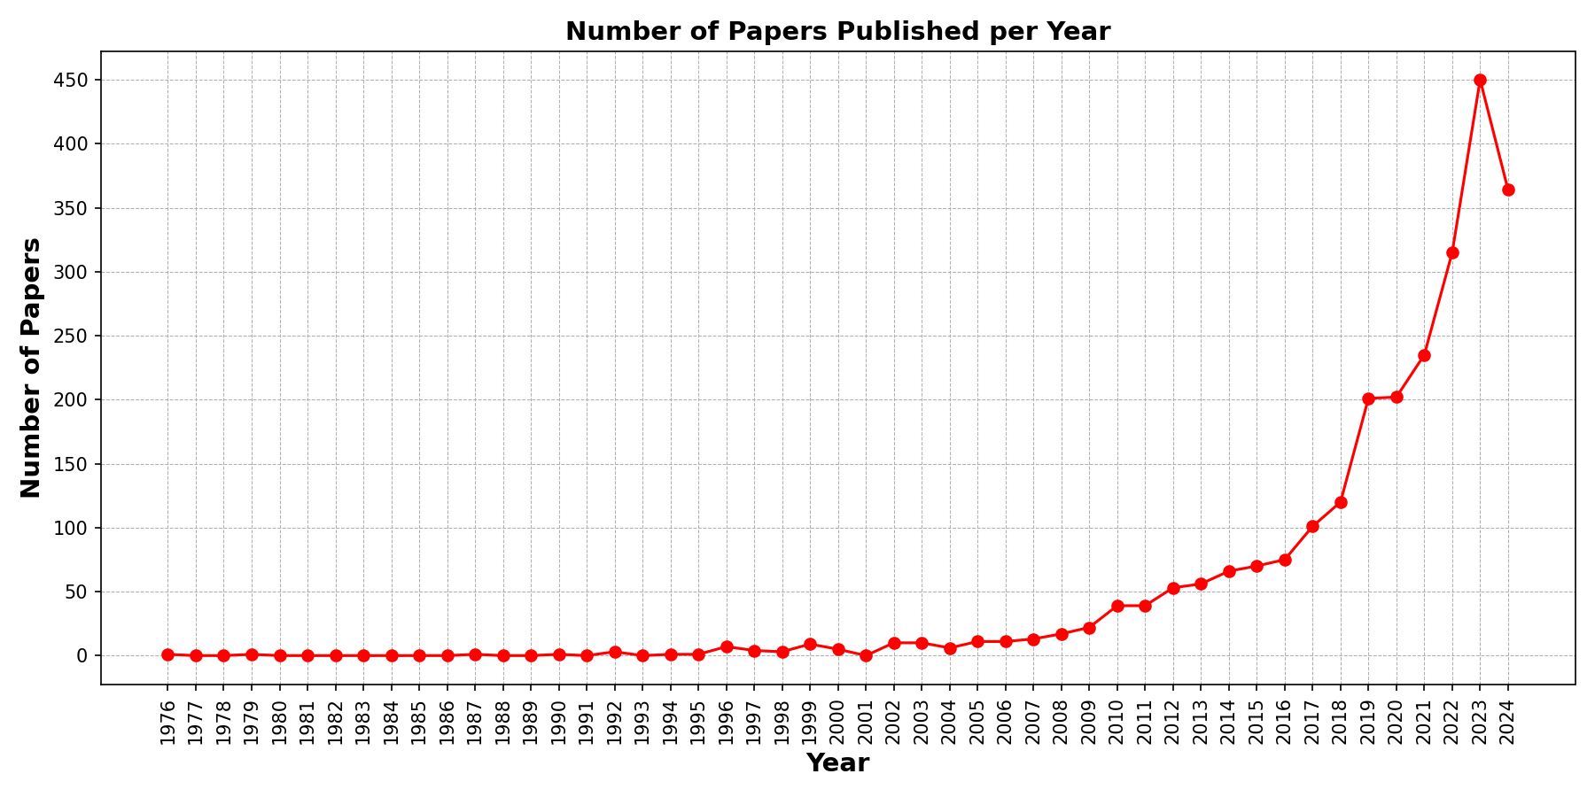

*Figure1-Trends in Publication over Time*

Observations:

This graph shows the trend in the number of papers published each year from 1976 to 2024. The x-axis represents the years, while the y-axis represents the number of papers published.

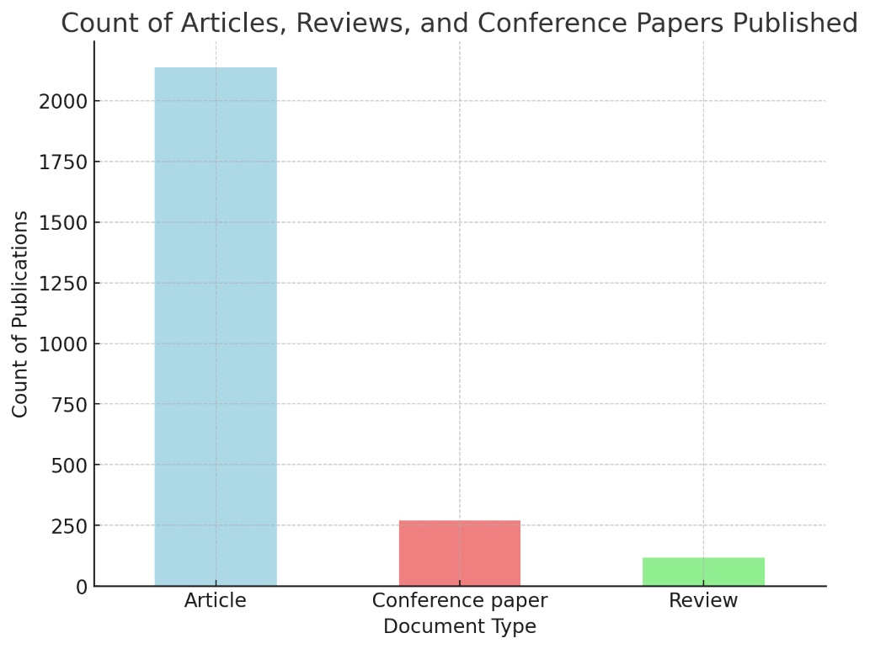

*Figure 2 - Count of document type (article, review, conference papers)*

Observations:

The above bar graph illustrates the distribution of three primary document types- articles, reviews and conference papers, published in various journals and conference proceedings. The classification is inferred from the titles of the sources, with journals categorized as "Articles," sources with "Review" in their titles classified as "Reviews," and sources containing "Conference" identified as "Conference Papers." This representation provides an overview of the types of scholarly contributions within the dataset.

*Figure 3-Pie chart depicting the percentage difference between open and non-open access.*

Observations:

The pie chart, shows that only 18% of the content is open access in various forms while majority i.e., 81.8% of content is non-open access.

The "Open Access" column reveals the distribution of access types:

1. Non-Open Access (NaN): 81.85% of the entries do not have open access.
2. Gold Open Access: 8.05% are fully open access under Gold Open Access license.
3. Bronze Open Access: 4.20% are open under Bronze Open Access license.
4. Hybrid Gold Open Access: 2.73% are open under hybrid model.
5. Green Open Access: 1.94% are open via Green Open Access.

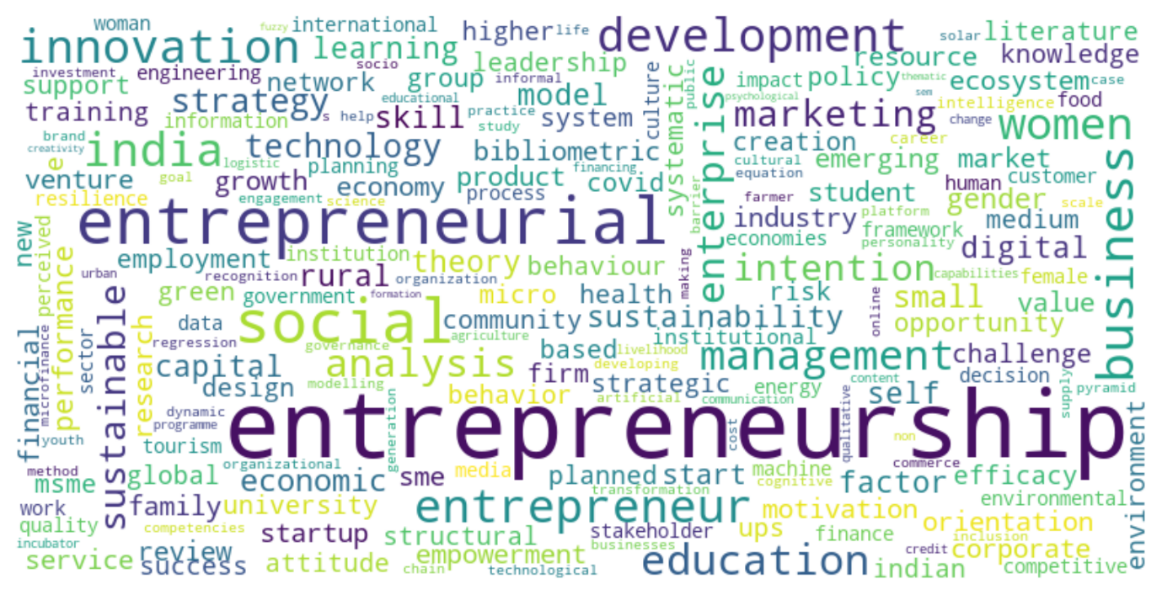

*Figure 4 - Word Cloud*

Observations:

The "Author Keywords" column contains keywords related to the main topics of each article, separated by semicolons.

The word cloud reflects the important themes in the dataset:

* Entrepreneurship and Entrepreneurial: These are the largest words, indicating they are frequent topics.
* Social, Innovation, Business, and Development: Other significant terms suggest a focus on social entrepreneurship, business innovation, and development.
* India and Gender: These terms highlight a geographic and social dimension, focusing on gender roles within entrepreneurship in India.
* Education, Strategy, and Management: These keywords reflect the academic and strategic aspects of entrepreneurial studies.

The dataset mainly focuses on topics like entrepreneurship, social impact, innovation, and business development. It also covers related themes like education, strategy, and gender roles in entrepreneurship, especially in India. The word cloud shows that these are the most common topics in the research.

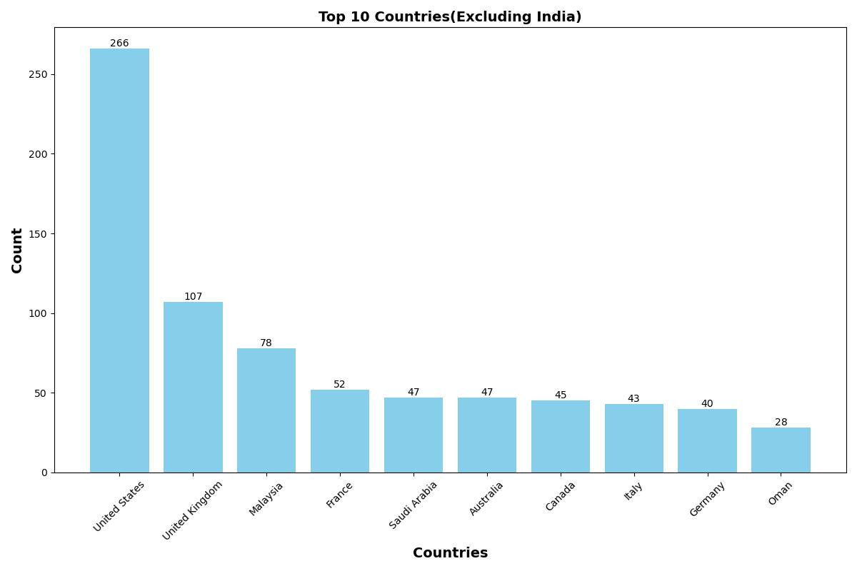

*Figure 5 -Top 10 Single Country Count*

Observations:

1. **United States** stands out as the most frequently mentioned country, with a significantly high count of 266. This suggests that a large number of affiliations are associated with institutions, researchers, or projects based in United States.
2. **United Kingdom** follows with a count of 107, but it is considerably lower than US.
3. Other countries like the **Malaysia** (78), **France** (52), **Saudi Arabia** (47), **Australia** (47), **Canada** (45), **Italy** (43), and **Germany** (40) appear as well, but their counts are relatively low, indicating fewer affiliations related to these countries in the dataset.

The data in the "Affiliations" column likely contains text entries with names of institutions or research organizations. The process involved extracting country names from these entries and counting the occurrences of each country. The presence of countries like United States, and others reflects the geographical distribution and concentration of affiliations in the dataset, with a notable predominance of US affiliations.

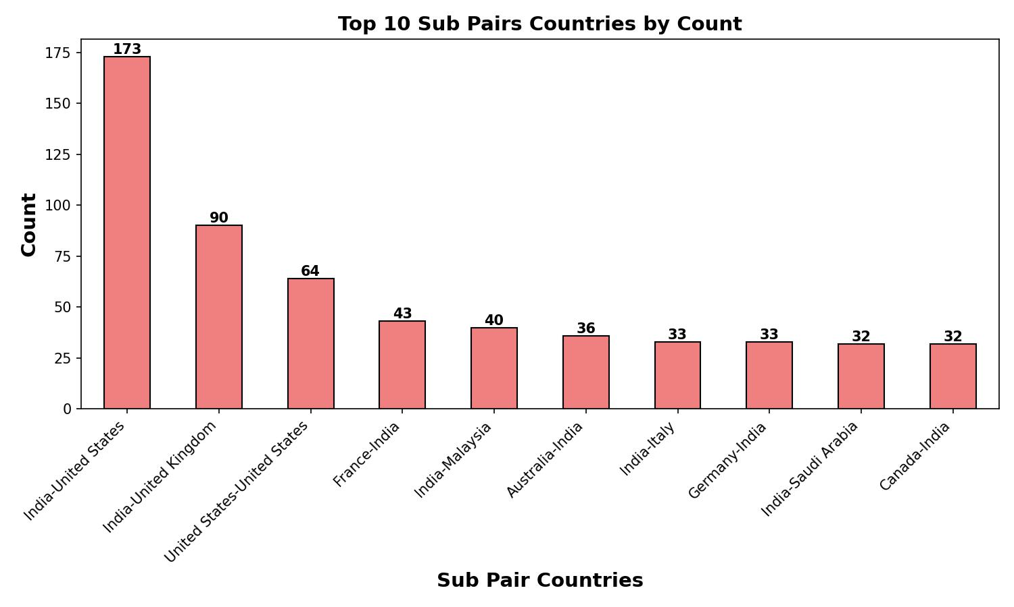

*Figure 6 - Top 10 Sub pair count in country pair*

Observations:

The plot shows the top 10 country pairs. **India-United States** has the highest count (173), showing a strong connection. Next is **India-United Kingdom** with 90 counts, followed by **United States-United States** (64), which could represent internal data.

Other pairs like **France-India** (43) and **India-Malaysia** (40) also show moderate interaction. The rest, such as **Australia-India, India-Italy, Germany-India, India-Saudi Arabia,** and **Canada-India,** have around 32–36 counts. Overall, India appears in most pairs, showing its importance in global connections.

**TABLES**

**Table 1 - Decade-Wise Research Trends**

|  |  |  |  |
| --- | --- | --- | --- |
| **Decade** | **Number of Papers** | **Total Citations** | **Average Citations** |
| 1999-2000 | 13 | 429 | 33 |
| 2001-2010 | 116 | 2728 | 23.51724 |
| 2011-2020 | 841 | 11475 | 13.64447 |
| 2021-2024 | 1147 | 5299 | 4.619878 |

Key observations:

1. Steady growth in research output: The number of papers has increased significantly from 13 in 1999-2000 to 1147 in 2021-2024, reflecting a growing interest in entrepreneurship and innovation research.
2. Declining average citations: While total citations increased proportionally with research output, the average citations per paper have steadily declined from 33 in 1999-2000 to 4.62 in 2021-2024. This decline might be due to the limited time newer papers have had to accumulate citations or the increasing volume of publications diluting impact.
3. Peak productivity: The period from 2011 to 2024 marks a significant boost in research, with over 1988 papers published and more than 16,774 citations generated.

**Table 2 - Author Position Analysis**

|  |  |  |  |
| --- | --- | --- | --- |
| **PID** | **Author Name** | **Author ID** | **Position** |
| 0 | Gupta, Brij B. (34770593700) | 3.48E+10 | first |
| 0 | Gaurav, Akshat (57195480314) | 5.72E+10 | middle |
| 0 | Arya, Varsha (57863028200) | 5.79E+10 | middle |

Key Observations:

Authorship positions provide insight into contributions within research projects. This data categorizes authors as first, middle, or last, reflecting their roles in the research. It includes:

* *First Authors*
* *Middle Authors*
* *Last Authors*

**Table 3 - Analysis of document type like article, review, conference papers.**

|  |  |  |  |  |  |
| --- | --- | --- | --- | --- | --- |
| **Document Type** | **No. of papers** | **%Papers** | **Total Citations** | **Open Access(1)** | **Non-Open Access(0)** |
| Article | 2138 | 84.74 | 20203 | 2138 | 1727 |
| Conference paper | 269 | 4.59 | 569 | 269 | 244 |
| Review | 116 | 10.66 | 1454 | 116 | 94 |

Key Observations:

The dataset categorizes publications by document type, revealing their distribution and citation impact:

Articles dominate the dataset, constituting **84.74% of the total papers**.

Reviews, though fewer in number, have a higher citation impact relative to conference papers.

**Table 4 – Top 10 countries count**

|  |  |
| --- | --- |
| **Country** | **Count** |
| United States | 266 |
| United Kingdom | 107 |
| Malaysia | 78 |
| France | 52 |
| Saudi Arabia | 47 |
| Australia | 47 |
| Canada | 45 |
| Italy | 43 |
| Germany | 40 |
| Oman | 28 |

Key Observations:

The United States has the most contributions (266) among these countries, followed by the United Kingdom (107) and Malaysia (78).

Countries like France, Saudi Arabia, and Australia are consistent contributors, while Oman shows growing interest with 28 contributions.

**Table 5 - Top 10 Sub Pair**

|  |  |
| --- | --- |
| **Sub Pair** | **Count** |
| India-United States | 173 |
| India-United Kingdom | 90 |
| United States-United States | 64 |
| France-India | 43 |
| India-Malaysia | 40 |
| Australia-India | 36 |
| India-Italy | 33 |
| Germany-India | 33 |
| India-Saudi Arabia | 32 |
| Canada-India | 32 |

Key Observations:

In this table we see that ‘India–United States’ and ‘India–United Kingdom’ lead the rankings.

From this conclusion we can say that High-frequency subpairs reflect strong bilateral research relationships.

**Table 6- Top 10 journals**

|  |  |  |  |
| --- | --- | --- | --- |
| **Journal Name** | **Publisher** | **No. of papers** | **Total citations** |
| Emerald Emerging Markets Case Studies | Emerald Group Publishing Ltd. | 85 | 82 |
| Emerald Emerging Markets Case Studies | Emerald Publishing | 75 | 14 |
| Emerald Emerging Markets Case Studies | Emerald Group Holdings Ltd. | 47 | 30 |
| International Journal of Entrepreneurship and Small Business | Inderscience Publishers | 40 | 160 |
| Journal of Engineering Education Transformations | Rajarambapu Institute Of Technology | 32 | 45 |
| International Journal of Business and Globalisation | Inderscience Publishers | 28 | 64 |
| World Review of Entrepreneurship, Management and Sustainable Development | Inderscience Publishers | 26 | 91 |
| Prabandhan: Indian Journal of Management | Associated Management Consultants Pvt. Ltd. | 22 | 77 |
| Journal of Advanced Research in Dynamical and Control Systems | Institute of Advanced Scientific Research, Inc. | 22 | 19 |
| Journal of Entrepreneurship | Sage Publications India Pvt. Ltd | 21 | 210 |

Key Observations:

The table shows top journals by papers and citations. Emerald Emerging Markets Case Studies leads with 207 papers but varying citation counts due to publisher inconsistencies. The International Journal of Entrepreneurship and Small Business (40 papers, 160 citations) and Journal of Entrepreneurship (21 papers, 210 citations) show strong impact.

Other contributors like the Journal of Engineering Education Transformations and World Review of Entrepreneurship have steady outputs with moderate citations. These journals cover diverse themes in entrepreneurship, management, and education.

**Table 7 - Top 10 Publishers**

|  |  |  |
| --- | --- | --- |
| **Publisher** | **Total Citations** | **Journal Count** |
| john wiley and sons ltd | 2488 | 177 |
| elsevier ltd | 2400 | 62 |
| emerald publishing | 2107 | 94 |
| elsevier inc. | 1902 | 13 |
| springer | 1605 | 52 |
| sage publications india pvt. ltd | 1274 | 54 |
| national institute of science communication and policy research | 1033 | 56 |
| inderscience publishers | 829 | 41 |
| multidisciplinary digital publishing institute (mdpi) | 820 | 19 |
| routledge | 487 | 40 |

Key Observations:

The table highlights the top publishers by citations and journal counts. **John Wiley and Sons Ltd** leads with 2488 citations across 177 journals, showing its dominant role. **Elsevier Ltd** follows with 2400 citations from just 62 journals, indicating high impact per journal. **Emerald Publishing** and **Springer** also contribute significantly with over 2000 and 1600 citations, respectively.

**Elsevier Inc.** stands out with 1902 citations from only 13 journals, suggesting very high-quality publications. Other notable contributors include **Sage Publications** and the **National Institute of Science Communication and Policy Research**, both with strong journal counts and steady citation numbers.

**CONCLUSION**

The growing interest in entrepreneurship research, particularly in India, reflects its critical role in driving economic growth, innovation, and job creation. The increasing volume of publications, global collaborations, and rising citation counts highlight the expanding impact of entrepreneurship studies. The analysis revealed that India is a central player in global research collaborations, especially with countries like the United States and the United Kingdom.

Despite this positive trend, challenges remain in ensuring the integrity and quality of research. Issues such as inconsistent data quality, variations in publisher names, and discrepancies in the reporting of open-access content need addressing. Additionally, while the overall number of publications has expanded rapidly, the citation impact of many papers has gradually declined, possibly due to the overwhelming volume of research being published.

Global partnerships, especially in emerging economies like India, offer a promising opportunity for improving research standards and fostering higher-quality publications. Collaborative efforts and academic networks could be key in overcoming challenges like limited peer review and the pressures on researchers to publish frequently.

In conclusion, while entrepreneurship research has made significant opportunity, continued efforts are needed to refine publication practices, improve global collaborations, and ensure that academic contributions maintain their relevance and quality.

**REFERENCES**

1. Gupta, S. (2018). *The role of technology in promoting entrepreneurship in India*. International Journal of Business and Globalisation, 21(4), 329–345.
2. Venkatesh, S., & Agarwal, S. (2019). *Women entrepreneurship in India: A study of challenges and opportunities*. International Journal of Entrepreneurship and Business Studies, 7(2), 89–103.
3. Smith, J., & Kumar, R. (2020). Trends in entrepreneurship research: A global analysis. Journal of Entrepreneurship Studies, 15(3), 123-135.
4. Prasad, V., & Joshi, R. (2021). *Startup India: A case study on the impact of government initiatives on entrepreneurship growth*. Journal of Business Research and Innovation, 6(3), 78–95.
5. Gupta, S. (2021). Global collaborations in entrepreneurship research. Springer.
6. Sharma, A. (2022). The role of open-access publishing in global research. Retrieved from [www.researchgate.net](https://www.researchgate.net)
7. Kumar, R., & Saini, P. (2022). *A bibliometric analysis of entrepreneurship research in India (2000–2020)*. Journal of Innovation and Entrepreneurship, 11(3), 243–267.